AWS Assessment Project 6

Project: Installing & Configuring Apache Tomcat Server on Linux

TASK 1: Create a Linux Instance

• Linux Instance Selection (Amazon Linux 2 AMI)

* Instance Details

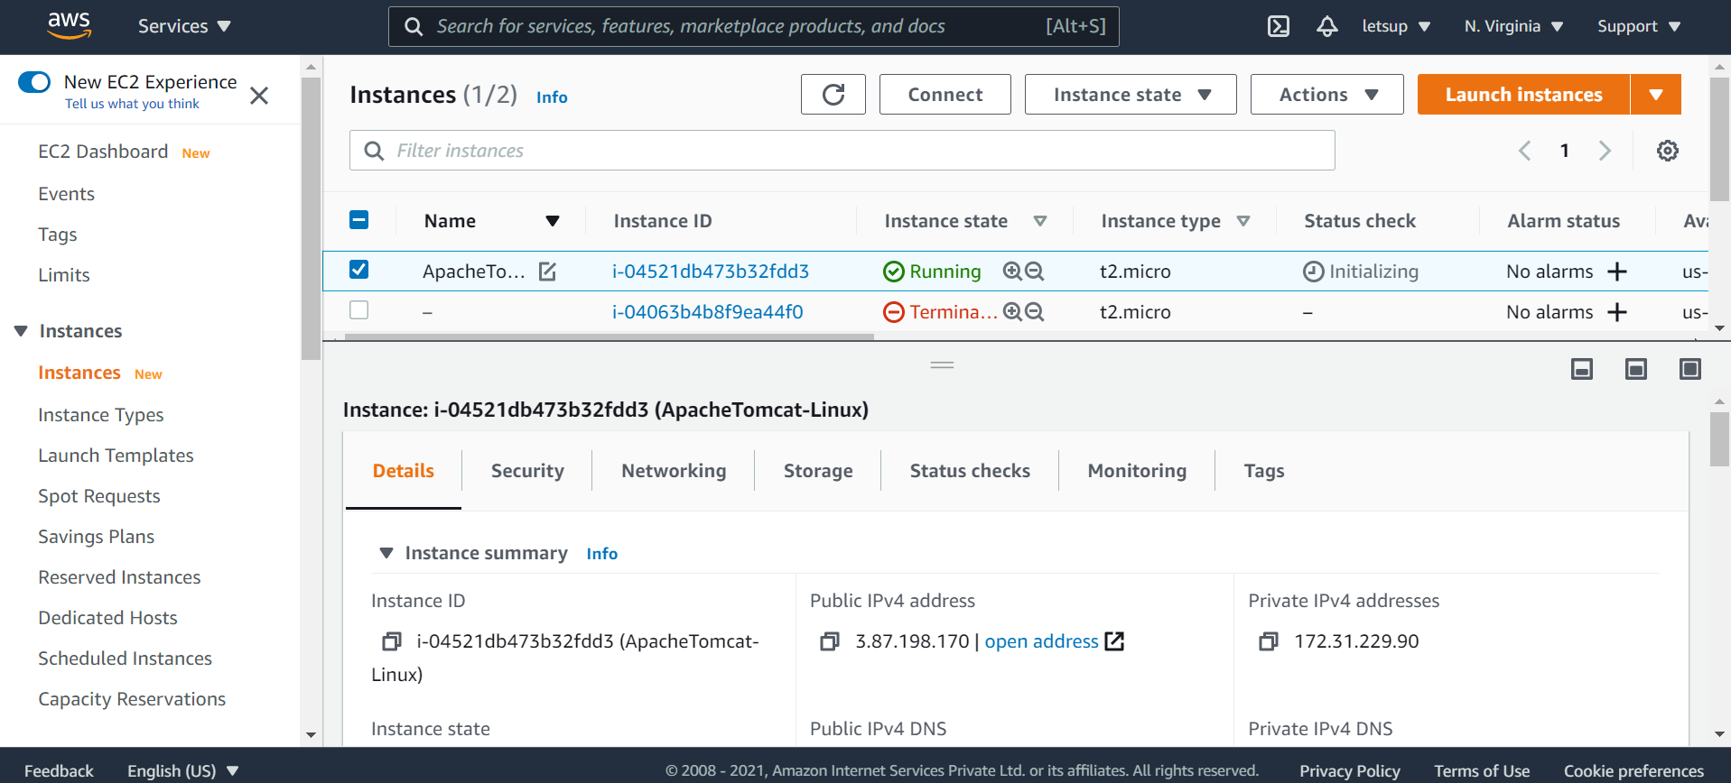

TASK 2: Install Java After connecting to the created instance:

• sudo su – Become superuser

* yum install java - Install Java

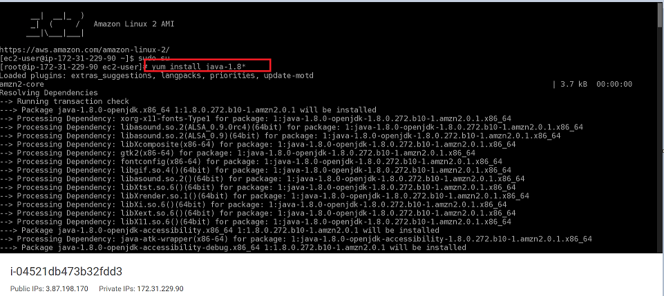

TASK 3: Install Tomcat

• cd /opt – Move to opt folder

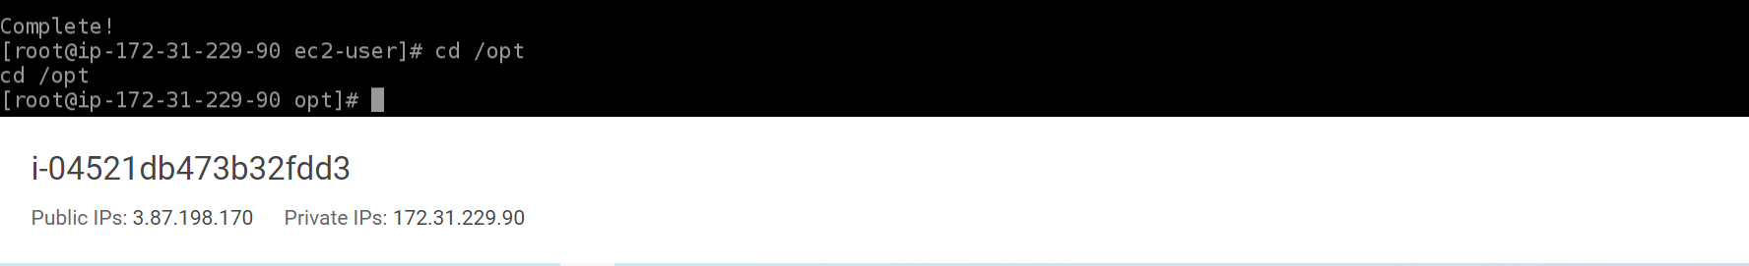

* Download Apache-Tomcat tar.gz file

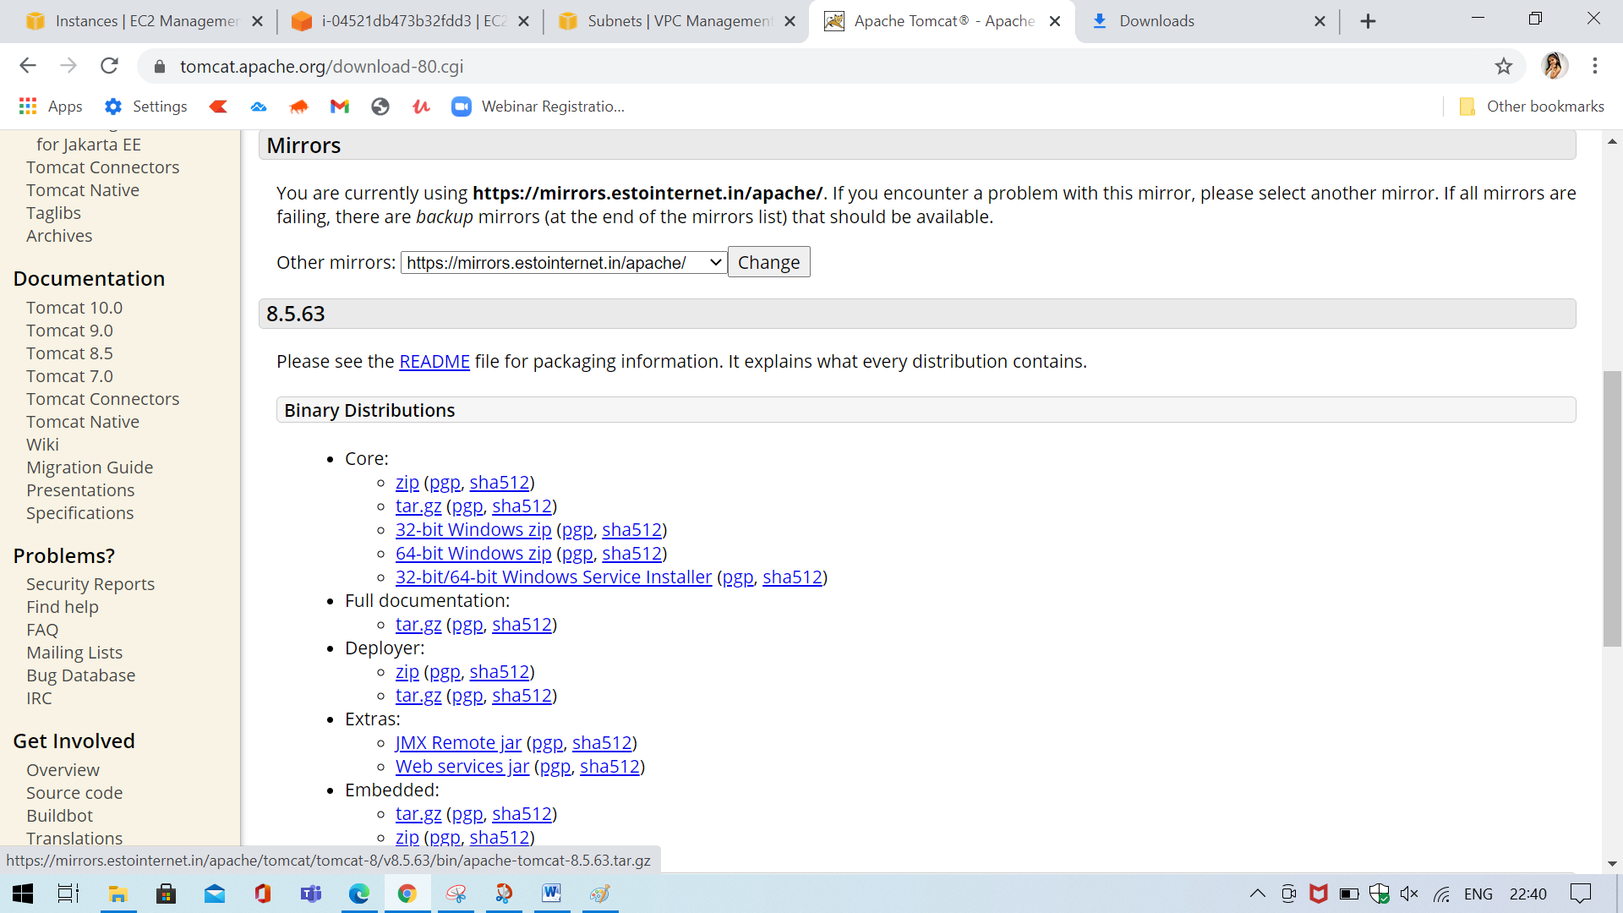

URL:

wget <https://mirrors.estointernet.in/apache/tomcat/tomcat8/v8.5.61/bin/apachetomcat-8.5.61.tar.gz>

* wget - To get the apache-tomcat file (Replace the URL with above URL path)

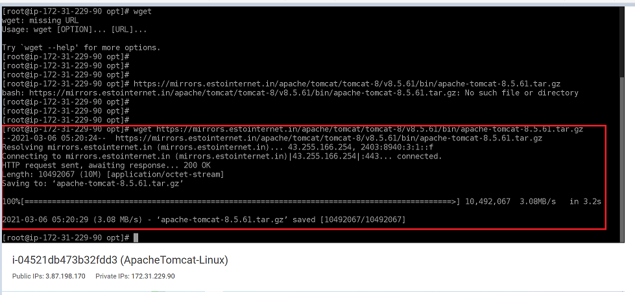

• tar -zvxf apache-tomcat-8.5.61.tar.gz - Extract apache-tomcat.tar.gz file

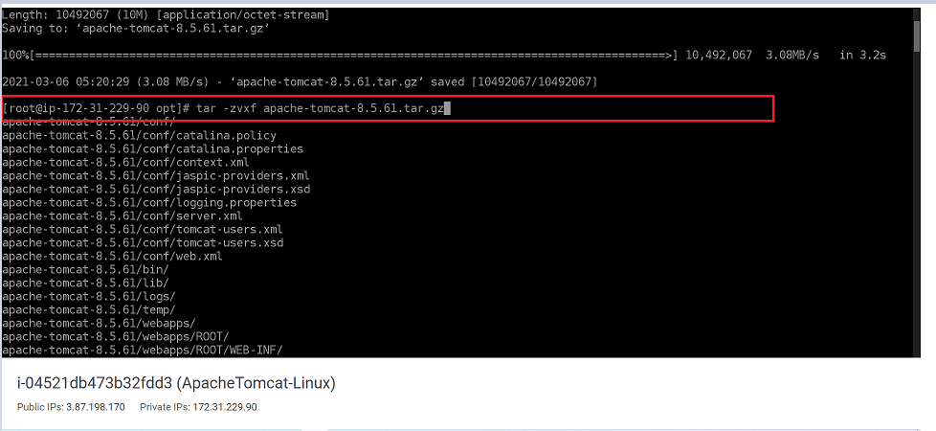

* cd bin - Go to bin folder
* ps -ef|grep tomcat – To check if tomcat process is running
* ls -ltr – To list files with their permissions
* Check file permissions of startup.sh and shutdown.sh

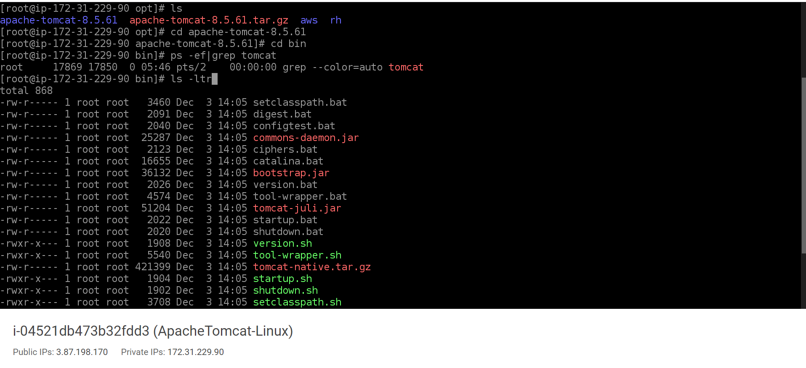

* Check file permissions of startup.sh and shutdown.sh

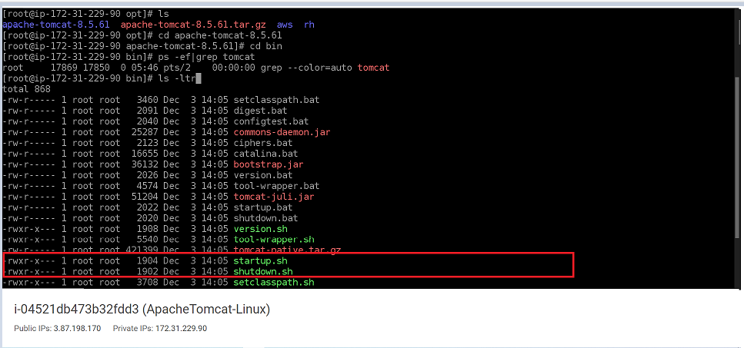

* Modify permissions for startup.sh and shutdown.sh

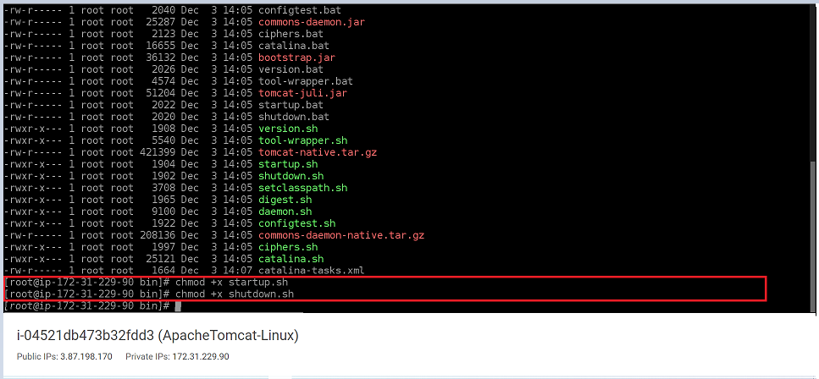

* Give execute permission to both the files:
* chmod +x startup.sh
* chmod +x shutdown.sh
* Create a softlink :

Note: soft link will help to execute the command from any folder need not to go specific folder to execute the file.

• find / -name startup.sh – To find the startup.sh path for soft link creation

Note: Use same path for creating soft link for shutdown.sh

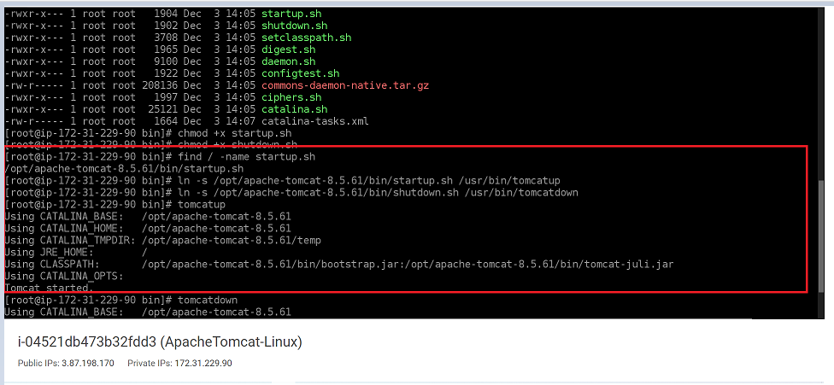

* Tomcat up softlink:

ln -s /opt/apache-tomcat-8.5.61/bin/startup.sh /usr/bin/tomcatup

* Tomcat down softlink:

ln -s /opt/apache-tomcat-8.5.61/bin/shutdown.sh /usr/bin/tomcatdown

* tomcatup – To start tomcat server
* tomcatdown – To stop tomcat server

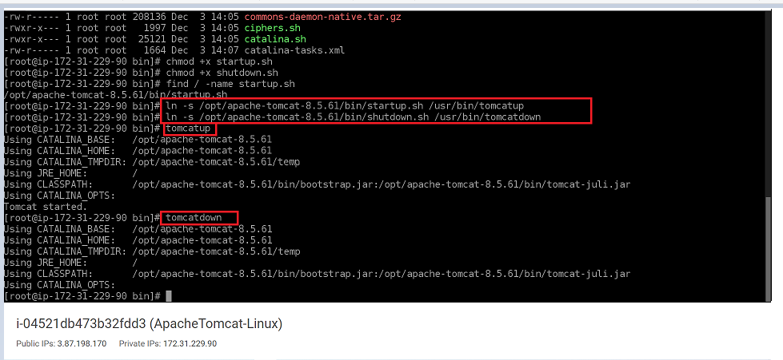

Note : Whenever you do changes, do ‘tomcatdown’ and then ‘tomcatup’ to see the impact of changes done.

• Change the port to 8090 in server.xml – Purpose is, it should not conflict with the Jenkins port 8080

• Go to server.xml path and edit server.xml

* cd .. – To come out of bin folder
* cd conf – To move into conf folder
* vi server.xml – To open the file for editing

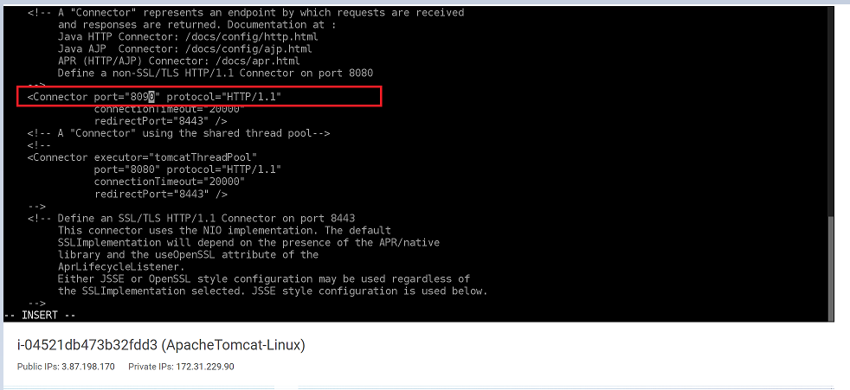

* Search for Connector port text and change the port from 8080 to 8090
* Save the file and restart tomcat(tomcatdown – tomcatup)

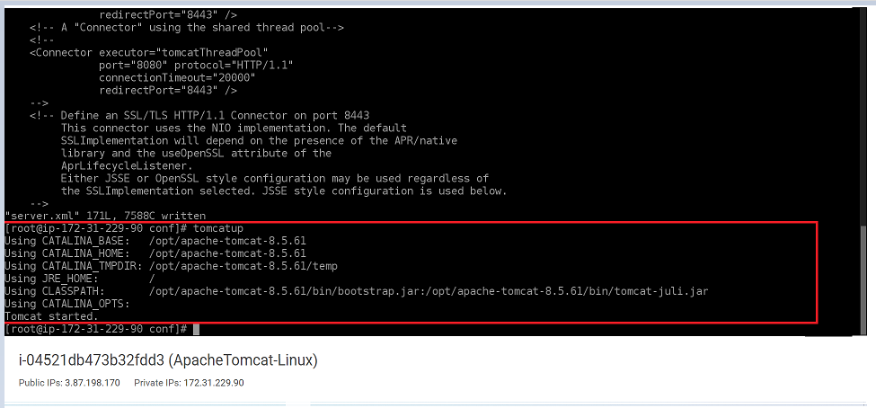

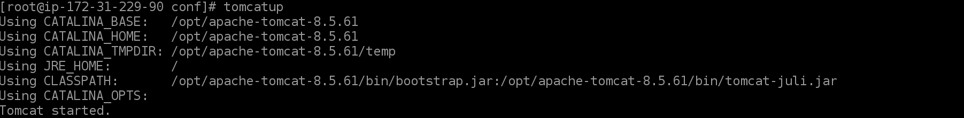

* Go to Internet Browser and type the public ip of Linux instance along with port number (3.87.198.170:8090) to check Apache Tomcat installation

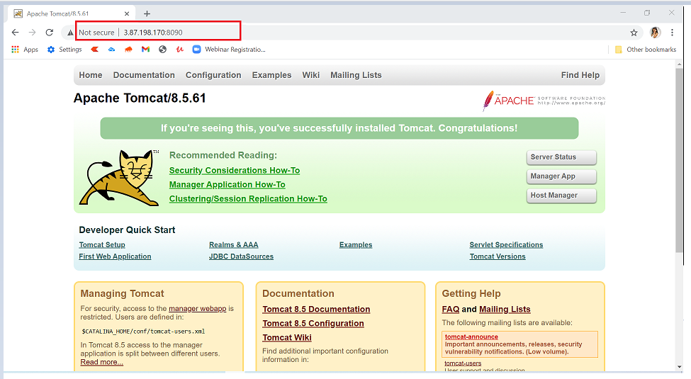

If you can see the Apache Tomcat page that means you have installed it properly Advance AWS Cloud Computing with DevOps Fundamentals 12

* To check the manager apps access type the following in browser address
* 3.87.198.170:8090/manager/html

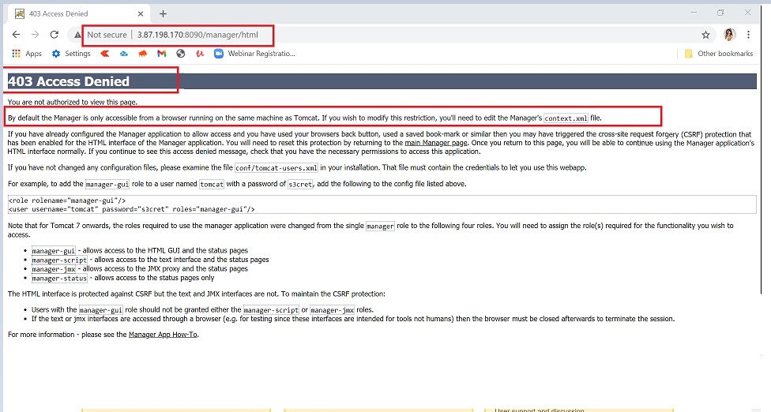

* If you see 403 Access Denied that means the manager app access is only allowed to specific IP mentioned in context.xml
* find / -name context.xml - to find the path of context.xml

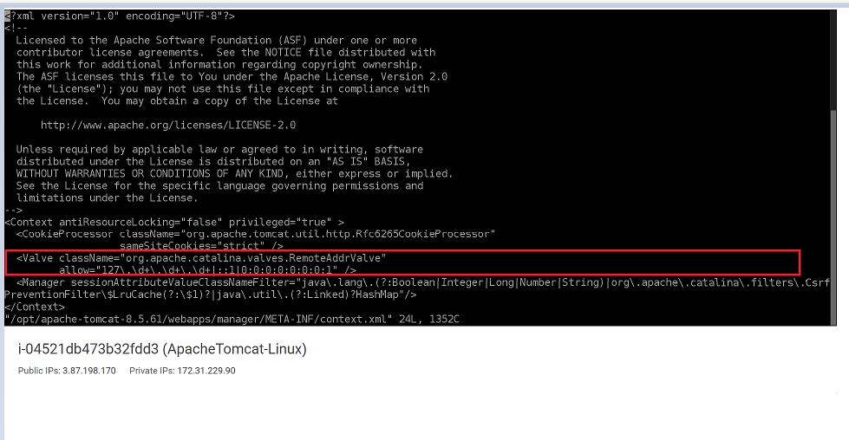

* vi /opt/apache-tomcat-8.5.61/webapps/manager/META-INF/context.xml – open the context.xml for editing

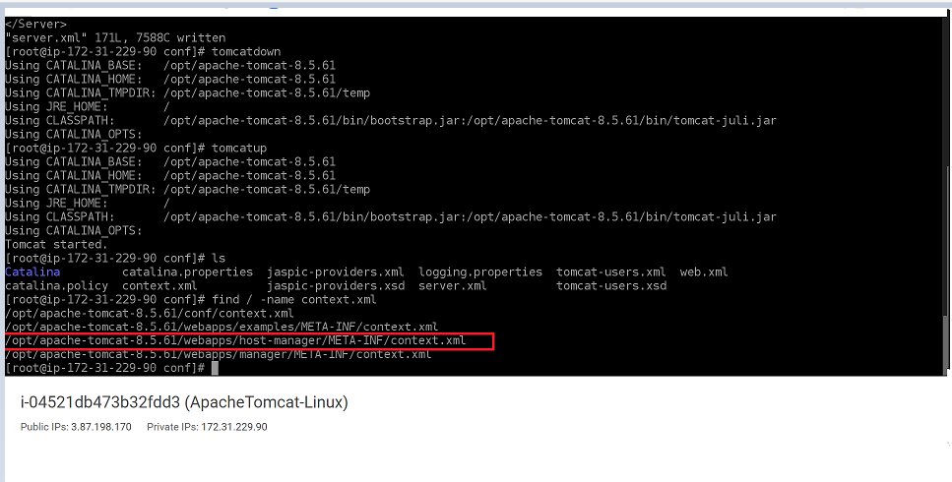

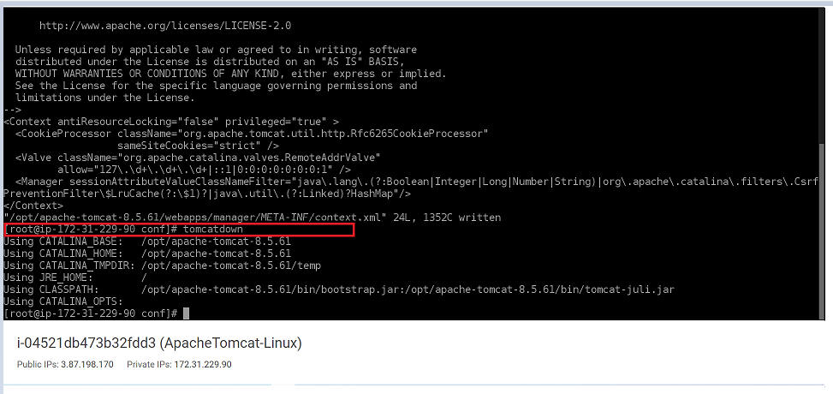

* After login you should be able to see the Tomcat Web Application Manager

